

**NEWEST ON THE BLOCK**

We would like to welcoming the lasted two family which were added to our community

-The Cardenas Family at 668 Neumann.

-The Valbuena-Laguna Family at

573 Neumann.

in the entrance sign and the tree trimming, sidewalk spray wash and the lawn cleanup of our park. Thank you and keep it up the great work!!!

**ABOUT THE ENTRANCE SIGN AND THE PARK**

We want to thank our new Board of Directors for the great job enhancing the community areas: the new lettering

**PRESIDENT** Dwayne_Mc Curvin lives at 591 Neumann Villages Ct

**TREASURE** Wosene Scott lives at 705 Neumann Village Ct

**SECRETARY** Ebony Germain lives at 700 Neumann Village Ct

-Last summer there was a new HOA Board of Director elected. Thank you to those that step up to accept to responsibility this time. This coming summer there is election time again, we encourage everybody in the neighborhood to consider to become an active member in the community as part of the HOA Board of Directors. The election is done by vote and usually happens during the summer HOA meeting at the West Oaks library

-Check the latest on our neighborhood at our Website: www.cambridgevillagehoa.com

-If you want to be added to our WhatsApp chat, please let the HOA board of Director know your phone number and request to be added.

**INFORMATION**

**WE ARE A DEED RESTRICTED COMMUNITY.**

A deed-restricted community is one in which a homeowners’ association outlines and enforces rules. Those rules can regulate the way the neighborhood or subdivision looks and the way the properties in it can be used. Ideally, the HOA is there to ensure the neighborhood stays in good shape, which helps keep home values where they should be. Deed-restricted communities charge homeowners a fee—in our case is semi-annually—to be part of the community. The Board of Directors are homeowners who volunteer their time and talents to keeping our neighborhood nice and beautiful.

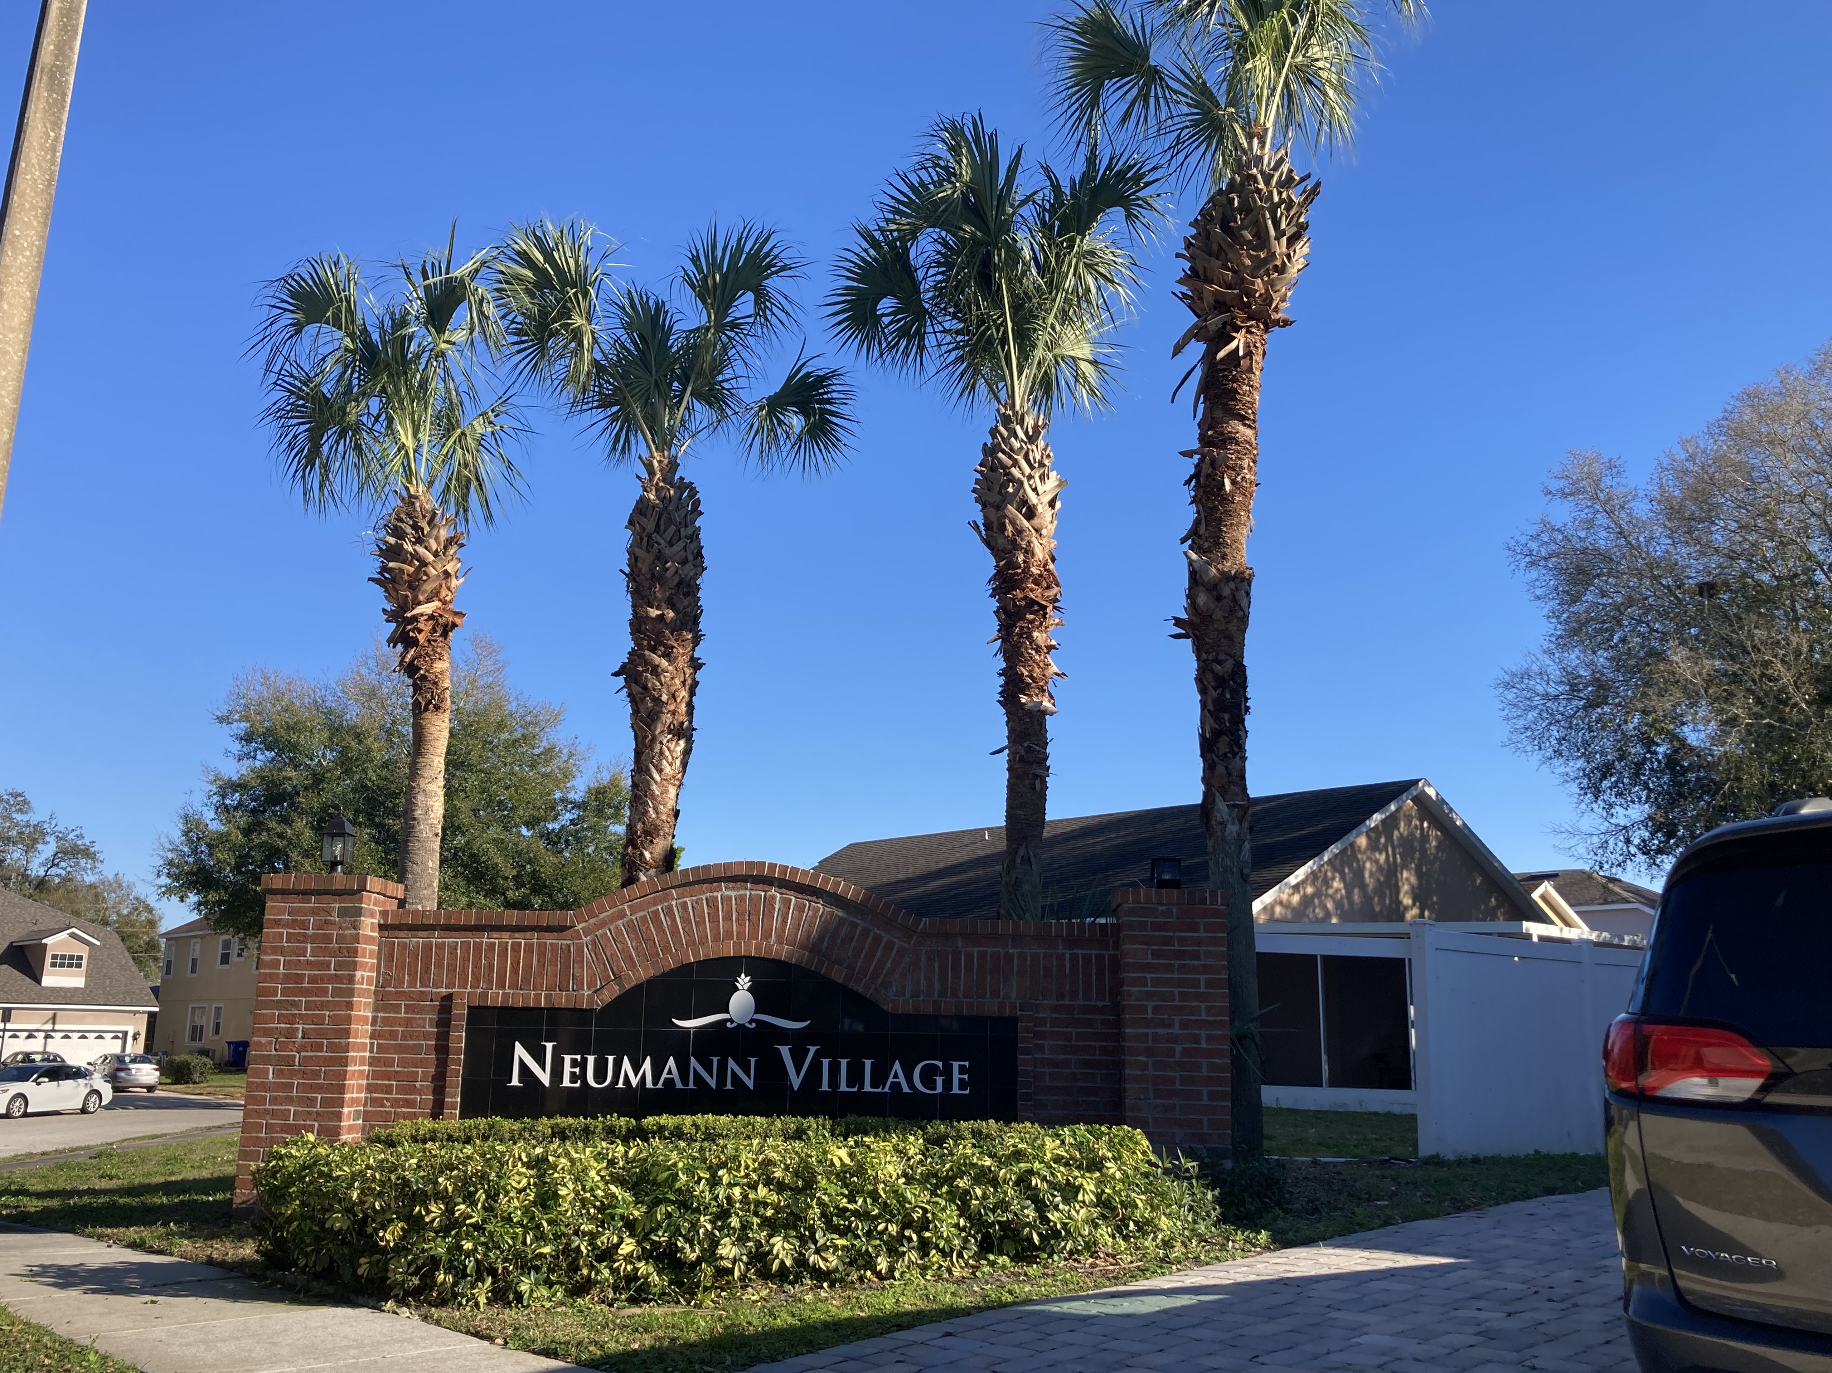

**LET’S CELEBRATE TOGHETER.**

We are going to have a potluck in the cul-de-sac on Saturday March 30TH at 3pm.

Everybody is invited to join us for food and fun. We are asking that everybody bring your favorite dish to share with everybody.

Contact XX if you have questions.

**CELEBRATION**

**EDUCATION**

**NEIGHBORHOOD NEWS**